Willis Ward’s Work at the Ford Motor Company

He was an executive in the Office of Industrial Relations and was charged with overseeing the employment and integration of “colored” workers at Ford. This led to a very complicated record on race relations. He joined Don Marshall, who was a black former police officer and friend of Harry Bennett. Marshall had a reputation as a “tyrant” with the black workers and was known to treat black workers who caused too much ruckus in the office to a beating. Other Ford executives described Don Marshall and Harry Bennett as having very similar temperaments but Willis Ward was a different sort, much more the college man and famous athlete who was good at public relations.

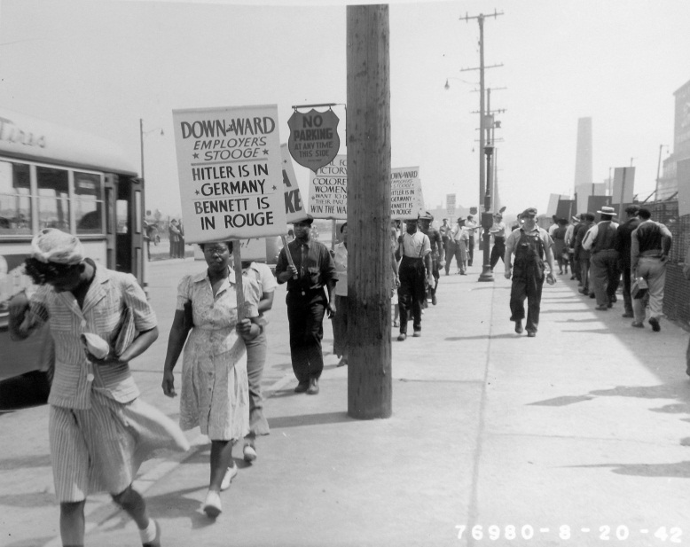
Henry Ford was very progressive with regard to his willingness to hire black workers and give them opportunities for advanced training but his policies were also very paternalistic, which led to abuses such as bribes, kickbacks and other corruptions, which Willis Ward describes in his memoirs.
Negroes protesting discrimination outside the
Rouge River plant in 1942
Courtesy of the Henry Ford Museum
(photo I.D. P.833.76980)

Willis Ward fought for black workers rights for equal treatment but he also gave in to the “realities” of the time. One example occurred in 1942, when many of the men were being drafted into the military. It was customary for the wife of a drafted white worker to be offered a job at Ford so that she could help support the family while her husband was fighting the war. When Willis Ward had to leave Ford for military service, his wife was given a job in the social services department working next to Henry Ford’s niece. However, there were plenty of available black men to hire and Willis Ward was concerned that if the proportion of black workers became too high that it would cause labor problems at Ford. Therefore, the wives of black workers were not offered jobs at Ford. This led to protests outside the gates of the Rouge River plant where the protesters carried signs that read;

Down with Ward
Employers’ Stooge
Hitler is in Germany
Bennett is in Rouge

In Ward’s own words most of the black workers thought of him as “a white folk’s nigger”. He said that only 5% of his community understood what he was doing to help black workers at Ford. He found that the loss of many friends in the black community was very hard on him and so, since he had completed his law degree in 1939, while working at Ford, he decided to leave Ford in 1946 and practice law. When Henry Ford Sr. died in 1947 and Henry Ford II took over the company, he fired Harry Bennett and all of his lieutenants.

Willis Ward was appointed by the Eisenhower administration as an assistant US Attorney in the Detroit office from 1952 until 1961. He made an unsuccessful run for congress in 1956 attempting to unseat Charles Diggs, a civil rights leader and first Chairman of the Congressional Black Caucus. He supported Governor Romney in his brief campaign against Barry Goldwater for the Presidency in 1964. He was rewarded with an appointment to the Board of Northern Michigan University and subsequently as a Commissioner of the Michigan Public Services Commission in 1966 by Romney. He served in that position until 1973 when he was appointed to a position as a probate court judge by Governor Milliken, perhaps with the urging of his friend, President Gerald Ford. He died in 1983 after a yearlong battle with cancer.

Willis Ward Oral History page 12
Willis Ward Oral History page 14
Willis Ward Oral History page 16
Willis Ward Oral History page 81
Willis Ward Oral History page 25
Willis Ward Oral History page83
Willis Ward Oral History page 100

